1. Identifier Naming Practice
Task: Write a program that declares variables for a student’s name, roll number, and marks in three subjects. Assign values and print them. Ensure all variable names follow Java identifier rules.
CODE-
public class Program1
{
public static void main(String args[])
{
int roll_no,Science,Maths,English;
String name;
Science=80;
Maths=70;
English=96;
name="Kanika";
roll_no=18;
System.out.println("Name="+name);
System.out.println("Roll no="+roll_no);
System.out.println("Science="+Science);
System.out.println("Maths="+Maths);
System.out.println("English="+English);
}
}

OUTPUT 1-
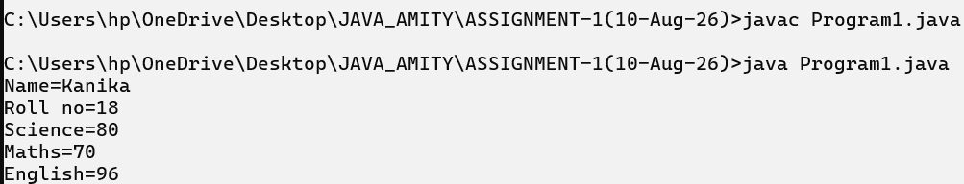

2. Data Type Conversion
Task: Write a Java program that: • Stores an integer value for temperature in Celsius.
• Converts it to Fahrenheit using the formula F = (C × 9/5) + 32.
• Displays both Celsius and Fahrenheit values.
CODE-
public class Program2
{
public static void main(String args[])
{
int celsius = 18;
double fahrenheit = (celsius * 9.0 / 5) + 32;
System.out.println("Celsius: " + celsius);
System.out.println("Fahrenheit: " + fahrenheit);
}
}

OUTPUT 2-

3. Arithmetic Operations
Task: Accept two integers from the user and perform addition, subtraction, multiplication, division, and modulus. Display results for each operation.
CODE-
import java.util.*;
public class Program3
{
public static void main(String args[])
{
Scanner in = new Scanner(System.in);
System.out.print("Enter first integer: ");
int a = in.nextInt();
System.out.print("Enter second integer: ");
int b = in.nextInt();
System.out.println("Addition: " + (a + b));
System.out.println("Subtraction: " + (a - b));
System.out.println("Multiplication: " + (a * b));
System.out.println("Division: " + (a / b));
System.out.println("Modulus: " + (a % b));
}
}

OUTPUT 3-
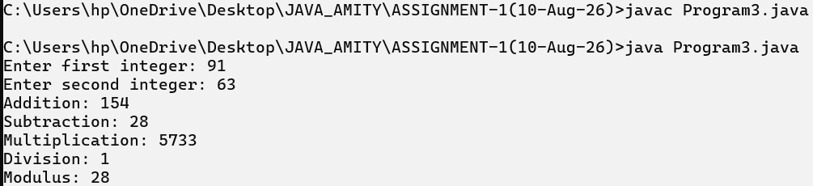

4. Logical Operators – Eligibility Check
Task: Write a program to check if a person is eligible to vote.
• Input: age and citizenship status (true or false).
• Use logical operators (&&, ||) to decide eligibility.
CODE-
import java.util.*;
public class Program4
{
public static void main(String args[])
{
Scanner in = new Scanner(System.in);
System.out.print("Enter age: ");
int age = in.nextInt();
System.out.println("Are you a citizen? (true/false): ");
boolean citizen = in.nextBoolean();
if (age >= 18 && citizen == true)
{
System.out.println("Eligible");
}
else
{
System.out.println("Not eligible");
}
}
}
OUTPUT 4-
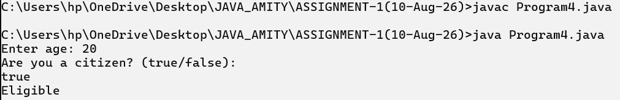
5. Control Statement – Simple Calculator
Task: Write a program that:
• Takes two numbers and an operator symbol (+, -, *, /) from the user.
• Uses if-else statements to perform the appropriate operation.
CODE-
import java.util.*;
public class Program5
{
public static void main(String args[])
{
Scanner in = new Scanner(System.in);
System.out.println("Enter first number: ");
double a = in.nextDouble();
System.out.println("Enter second number: ");
double b = in.nextDouble();
System.out.println("Enter operator (+, -, *, /): ");
char operator = in.next().charAt(0);
if (operator == '+')
{
System.out.println("Result: " + (a + b));
}
else if (operator == '-')
{
System.out.println("Result: " + (a - b));
}
else if (operator == '*')
{
System.out.println("Result: " + (a * b));
}
else if (operator == '/')
{
System.out.println("Result: " + (a / b));
}
else
{
System.out.println("Invalid operator");
}
}
}

OUTPUT 5-
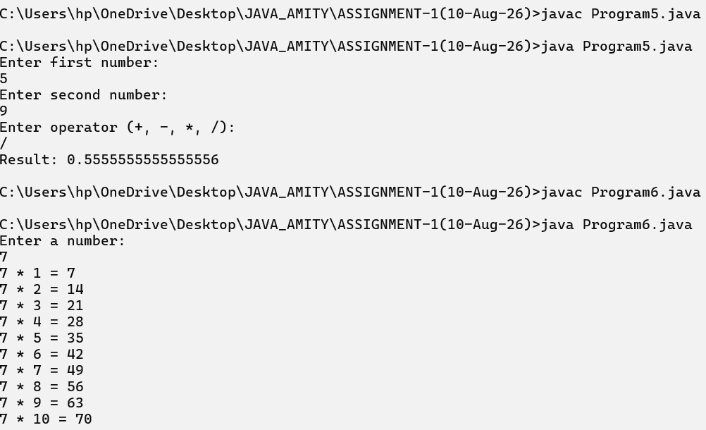
6. Loop – Multiplication Table
Task: Ask the user for a number and print its multiplication table from 1 to 10 using a for loop.
CODE-
import java.util.*;
public class Program6
{
public static void main(String args[])
{
Scanner in = new Scanner(System.in);
System.out.println("Enter a number: ");
int number = in.nextInt();
for (int i = 1; i <= 10; i++)
{
System.out.println(number + " * " + i + " = " + (number * i));
}
}
}

OUTPUT 6-
7. Loop with Conditional – Sum of Even Numbers
Task: Write a program that uses a while loop to find the sum of all even numbers between 1 and 50.
CODE-
OUTPUT 7-
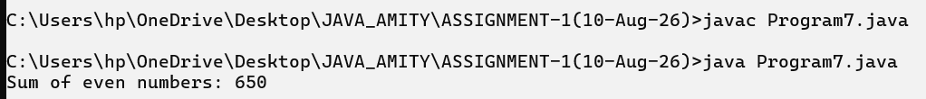
8. Arrays – Store and Print Marks
Task: Write a program that:
• Reads marks of 5 students into an integer array.
• Prints each student’s marks.
CODE-
public class Program7
{
public static void main(String args[])
{
int number = 1;
int sum = 0;
while (number <= 50)
{
if (number % 2 == 0)
{
sum = sum + number;
}
number++;
}

System.out.println("Sum of even numbers: " + sum);
}
}

OUTPUT 8-
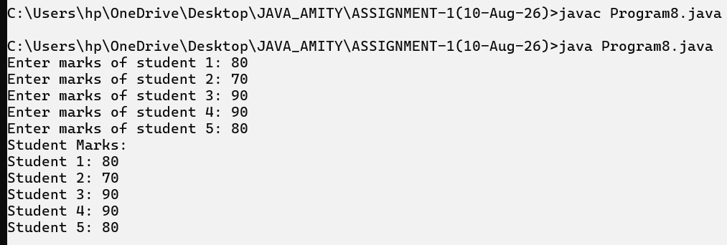
9. Arrays and Loops – Find Maximum
Task: Write a program to read 10 integers into an array and find the maximum value using a loop.
CODE-
import java.util.*;
public class Program9
{
public static void main(String args[])
{
Scanner in = new Scanner(System.in);
int[] numbers = new int[10];
for (int i = 0; i < 10; i++)
{
System.out.print("Enter number " + (i + 1) + ": ");
numbers[i] = in.nextInt();
}
int maximum = numbers[0];
for (int i = 1; i < 10; i++)
{
if (numbers[i] > maximum)
{
maximum = numbers[i];
}
}

System.out.println("Maximum value: " + maximum);
}
}

OUTPUT 9-
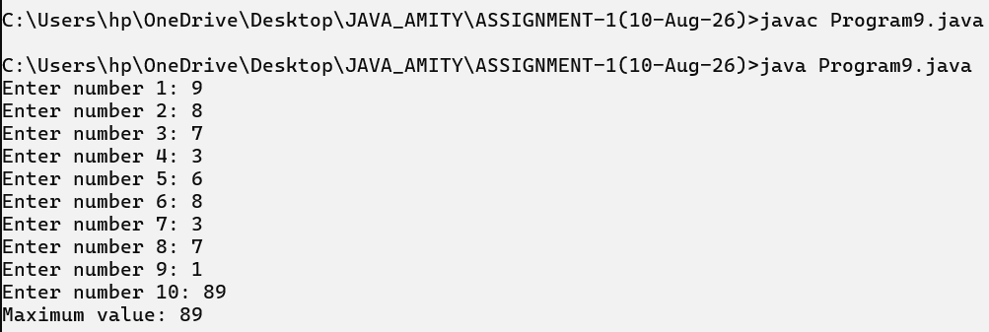
10. Mini Project – Average and Grade
Task: Write a program that:
• Reads marks of 5 subjects into an array.
• Calculates the average marks.
• Uses if-else to assign grades:
o >= 90: A
o >= 75: B
o >= 50: C
o Else: Fail
CODE-
import java.util.*;
public class Program10
{
public static void main(String args[])
{
Scanner in = new Scanner(System.in);
int[] marks = new int[5];
int sum = 0;
for (int i = 0; i < 5; i++)
{
System.out.print("Enter marks of subject " + (i + 1) + ": ");
marks[i] = in.nextInt();
sum = sum + marks[i];
}
double average = sum / 5.0;
System.out.println("Average Marks: " + average);
if (average >= 90)
{
System.out.println("Grade: A");
}
else if (average >= 75)
{
System.out.println("Grade: B");
}
else if (average >= 50)
{
System.out.println("Grade: C");
}
else
{
System.out.println("Grade: Fail");
}
}
}

OUTPUT 10-
